**Business Brief for game company funding**

Our team has decided that we will need a minimum of $15,000 USD to get this project off the ground. We have ambitions of expanding the business and would like to maximize our funding for this campaign. Therefore, we have conducted a market research on all the different categories especially in gaming category to analyze our goals.

We have done a list of Preliminary Data Analysis which are as follow:

We have seen that the average goal for successful outcomes were almost 10 times less than the failed outcome. Therefore, it’s best to keep realistic goals and not over hype the funding goals.

Top three sub-categories with most backers are Product design, documentary and music. Least 3 sub-categories by backers are Letterpress, Taxidermy and Glass.

The top 3 categories with most backers are Games, Technology and Design. Least 3 category with backers are Dance, Journalism, Crafts

The top 3 sub-categories that have raised the most money are Comics, Dance and Fashion and the least 3 subcategories that have raised the money are Publishing, Technology and Photography.

The most successful game company is HIIT Bottle as it was able to raise 124998 USD for their 15000 USD goal which was supported by 2784 backers.

The Top three countries with the most successful campaigns in terms of dollars (total amount pledged) are USA and NO.

The Top three countries with the most successful campaigns in terms of backers are USA, GB and AU.

We have also been able to see that shorter campaigns were able to raise more money than longer campaigns. The difference was almost 10 times compared to the average time period.

Goal set country wise for gaming category:

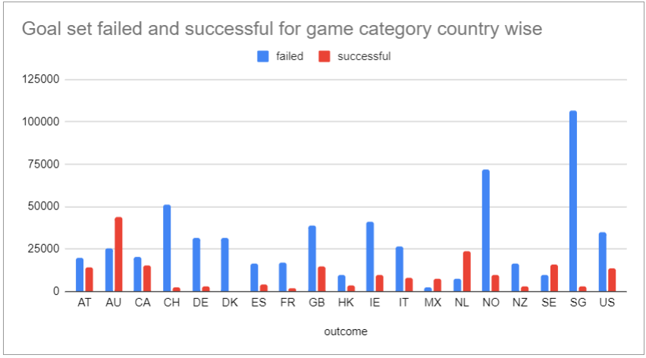

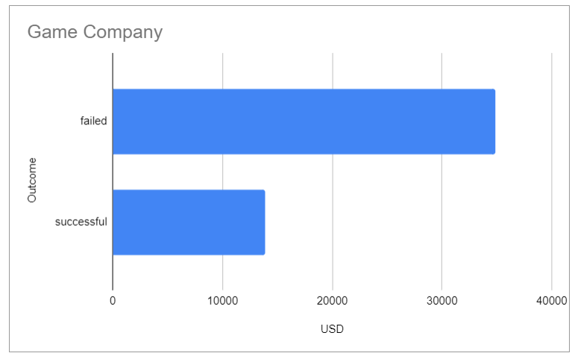

We can see that for the US where the amount is spent in dollars, the average goal set by the gaming companies is approximately 13893 USD.

Comparison of different outcomes for different categories as per the average backers.

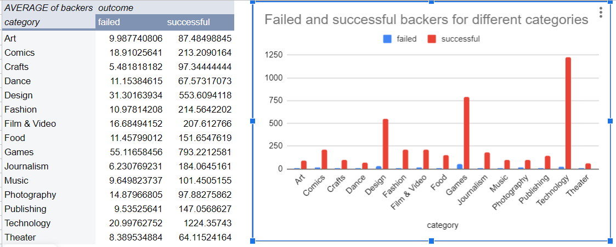

Approximate backers required for the success of the gaming category:

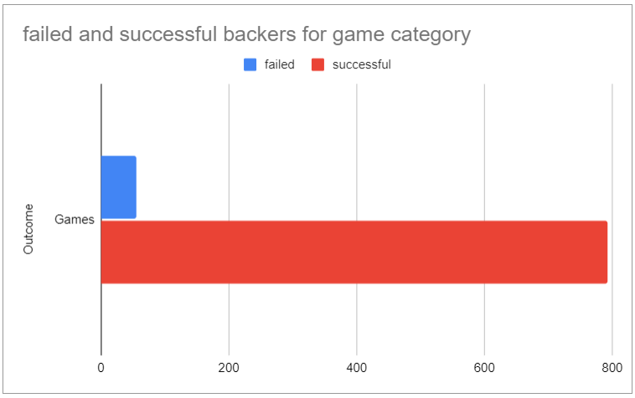

Here we can see that the gaming category requires an average of 793 backers in order to be successful. Therefore, this will be our target to meet our goals.